**BINARY TO DECIMAL CONVERSION**

**EXP NO: 26**

**AIM:**To write a C program to implement binary to decimal conversion. **ALGORITHM:**

1. Start
2. Read the binary number from the user, say ‘n’
3. Initialize the decimal number, d=0
4. Initialize i=0
5. Repeat while n != 0:

i. Extract the last digit by: remainder = n % 10 ii. n = n/10

iii. d = d + (remainder * 2<sup>i</sup>) iv. Increment i by 1

1. Display the decimal number, d
2. Stop

**PROGRAM:**

#include <stdio.h> void main()

{

int num, binary_num, decimal_num = 0, base

= 1, rem;

printf (" Enter a binary number with the combination of 0s and 1s \n"); scanf (" %d", &num); binary_num = num;

while ( num > 0)

{

rem = num % 10;

decimal_num = decimal_num + rem * base; num = num / 10; base = base * 2;

}

printf ( " The binary number is %d \t", binary_num); printf (" \n The decimal number is %d \t", decimal_num);

}

**INPUT & OUTPUT:**

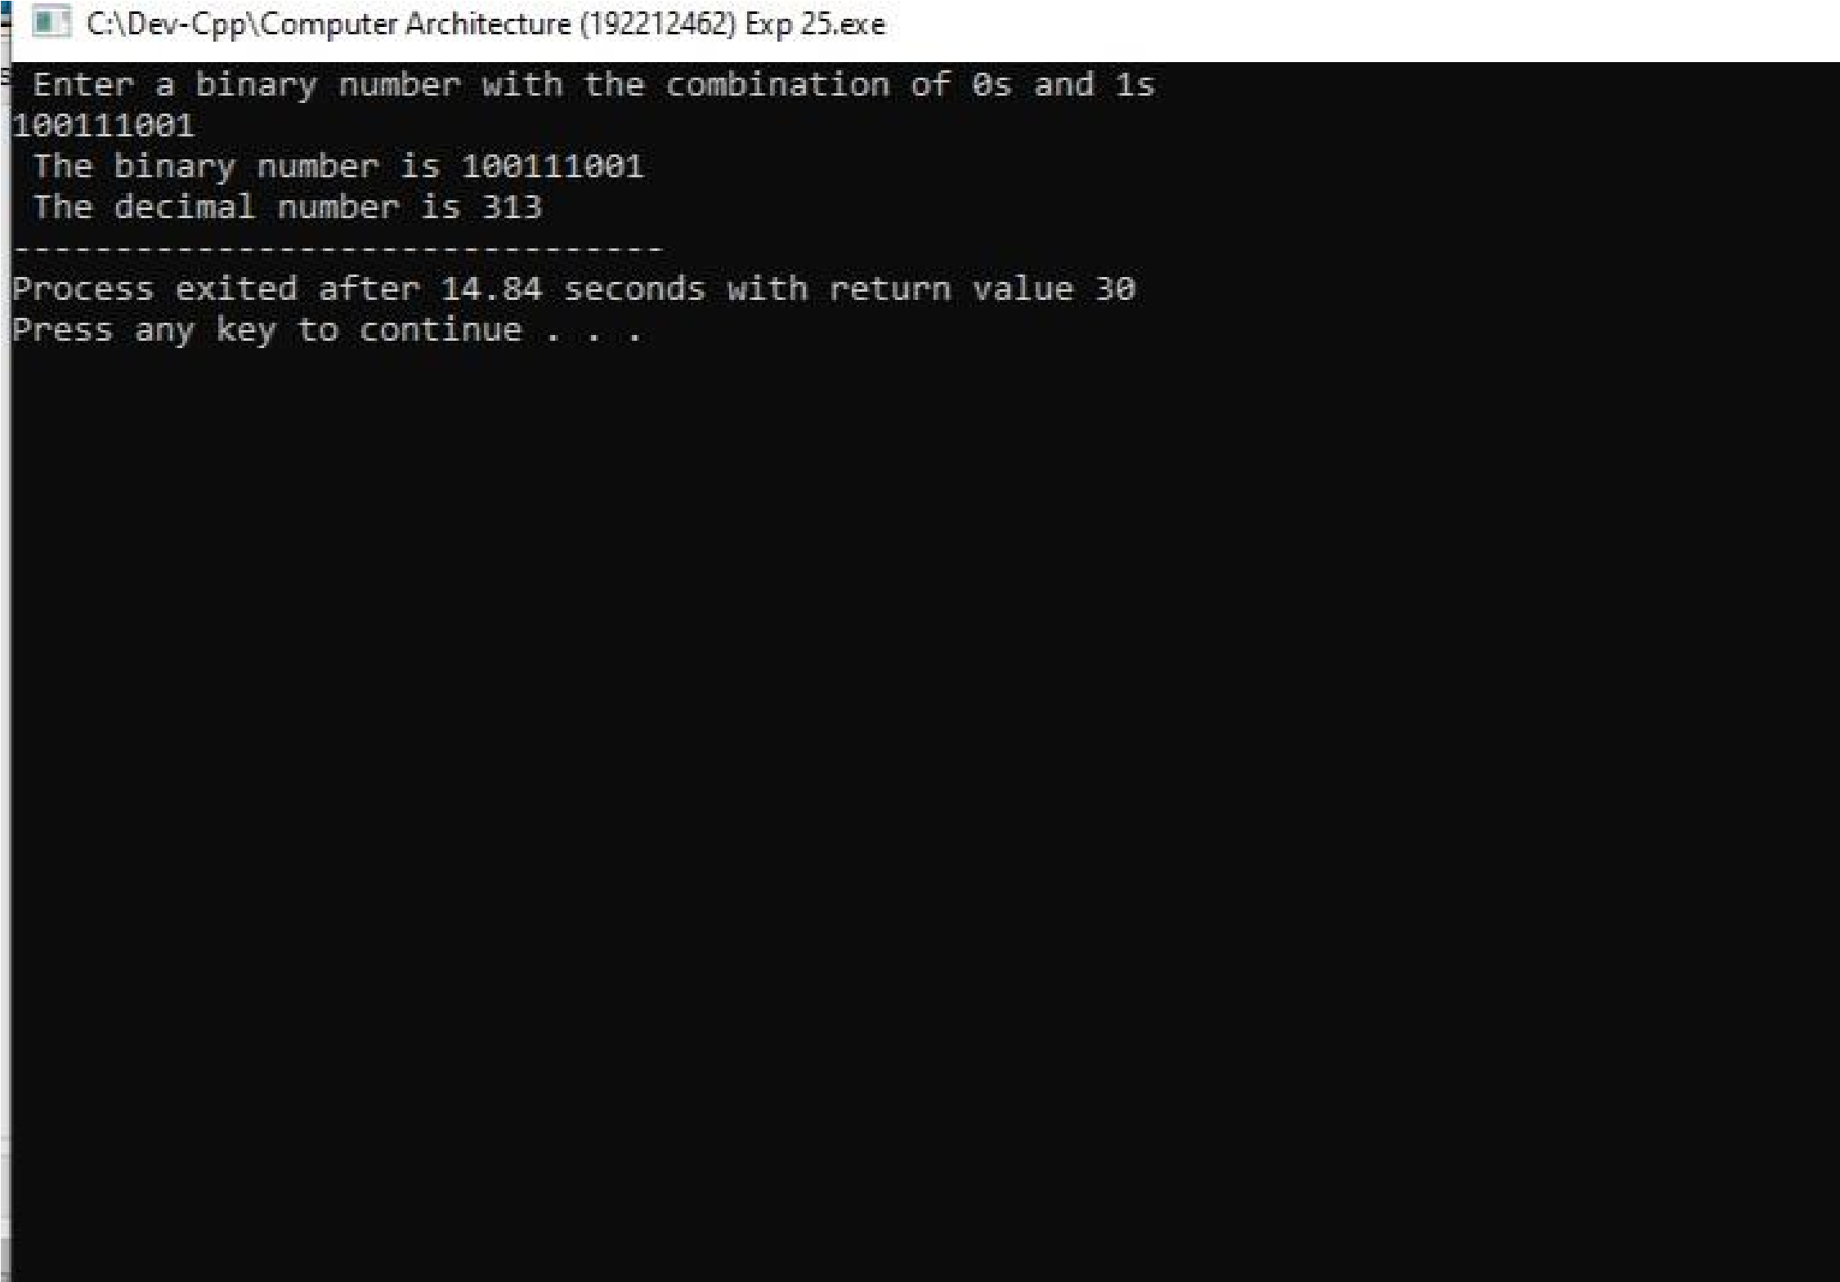**RESULT:** Thus the program was executed successfully using DevC++.